-- Module 1: The Basics & Time Series
-- YoY sales and profit growth:

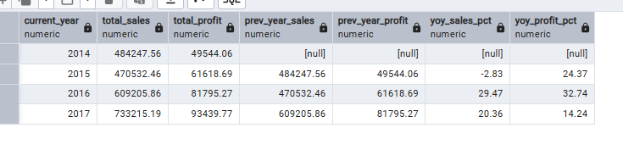
-- Seasonality Weekend effect total sales and total return:

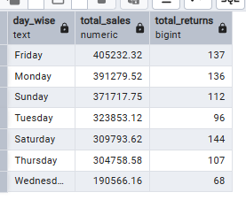

-- Best quarter year total sales:

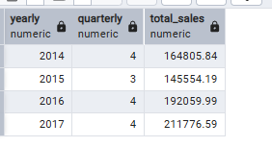

-- Module 2: Profit Bleeding (Where are we losing money?)
-- Where we are losing money [Discount trap]:

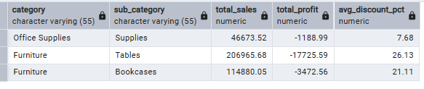

-- Return problems in regions with return pct:

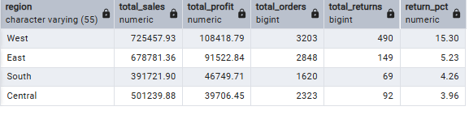

-- Top 10 loss making customers:

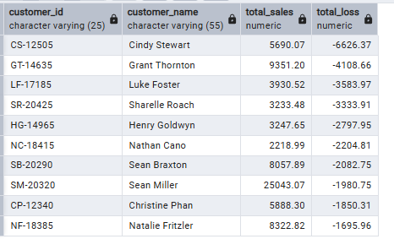

--Module 3: Advanced Supply Chain & Logistics
-- Shipping Delay Analysis:

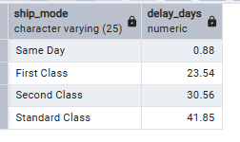

-- Late delivery Impact Compare on time vs late returns:

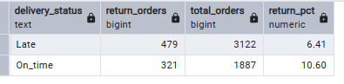

-- Salesperson performance:

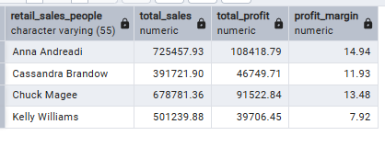

-- (Window Functions & CTEs)
-- Churn customers : placed order in 2015 & 2016 but never placed in 2017:

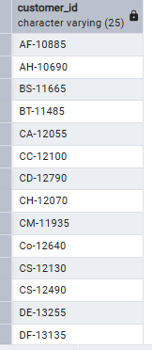

-- 30 days Moving average:

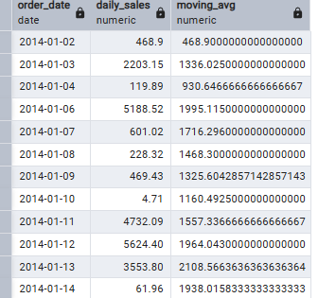

-- Customer Segmentation:

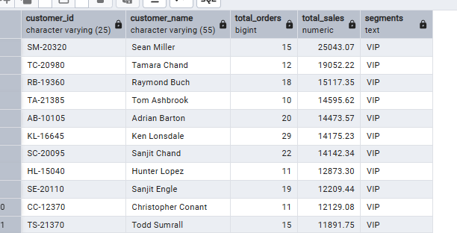

-- MoM growth with pct:

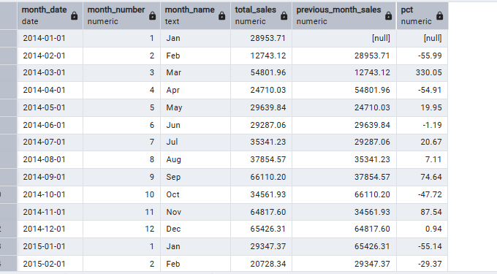

-- Most profitable route:

